


Our Next Club Meeting - This Thursday evening, Dec 11th at 6:30 pm. Black Bear Diner - 1830 Arden Way, Sacramento.
Program: Allie Dumas, Center for Land Based Learning. Allie leads the Student & Landowner, Education & Watershed Stewardship program in Northern California. She supports high school students in learning about their local environment, exposing them to college and career opportunities in the field of environmental science.

https://www.landbasedlearning.org/

President’s Message
Our schedules can be so hectic this time of year. In addition to work and family events we have our evening Kiwanis meeting this week, our club Christmas Social this Friday, and Salvation Army bell ringing on Saturday (volunteer schedule below). It can be a little overwhelming but, that being said, there are so many people who would love to be in our shoes. Please keep the people that CAFFE serves and the families staying at the Kiwanis Family House in your hearts. CAFFE is looking for anything warm to wear in addition to blankets and sleeping bags. It's a great time to go through your closet. You can contact Armando directly at: Seven01Armando@hotmail.com or bring the items to our Christmas party. Additionally, the Kiwanis Family House has needs as well. You can find their wish list here: Wish List – KFH – Kiwanis Family House . We will collect CAFFE and KFH items at our Christmas party.

Don't forget, we are now into full-on Crab Feed time. Contact your friends and family. We would really like to add an additional 50 people to this year’s participants. Also, don't forget to solicit for donations (Wine and raffle items). The more interesting the prizes the more tickets we sell! More funds raised equals more ways we can provide community service!

-Dave

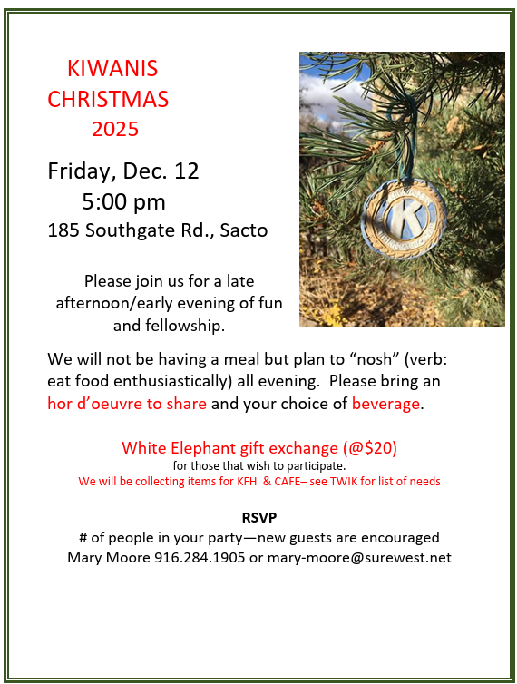

Babcock School had another free book giveaway on Tuesday, November 18th. Thanks to John Perryman and Jennifer Ngo for organizing and volunteering for this terrific service project.
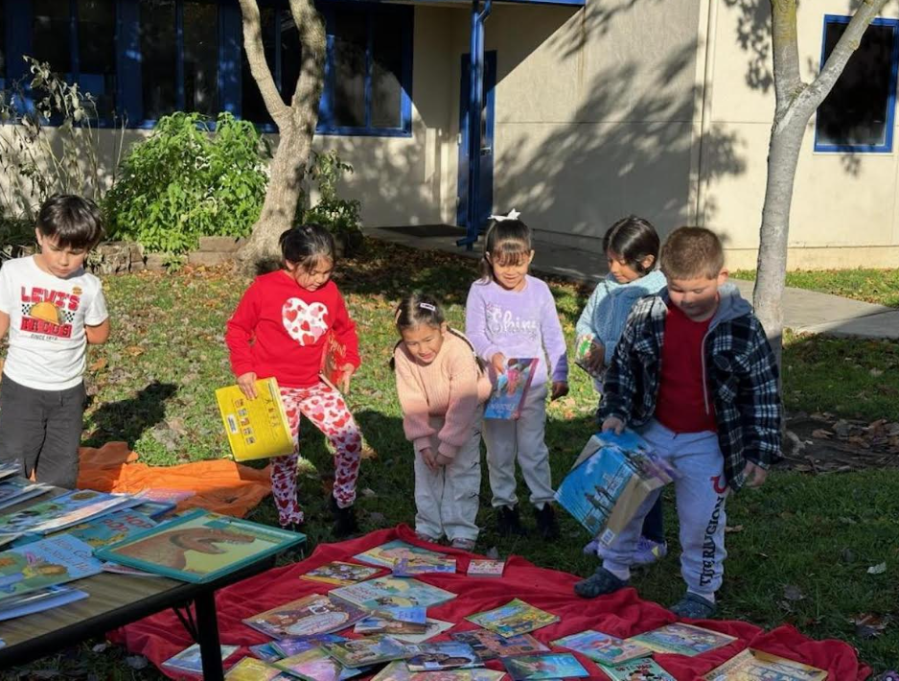
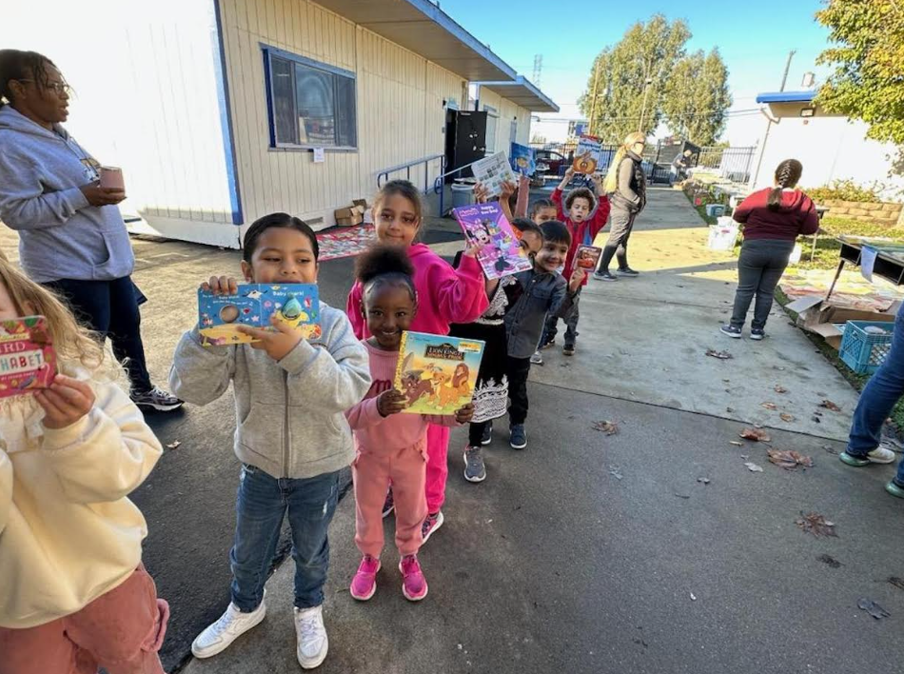

Appreciation Lunch for Teachers at Babcock School took place on Thursday, Nov 20th. Thanks to volunteers John and Paulette Draper, Dave Canady, John Perryman, Marty Maxwell and Carolyn Baker!
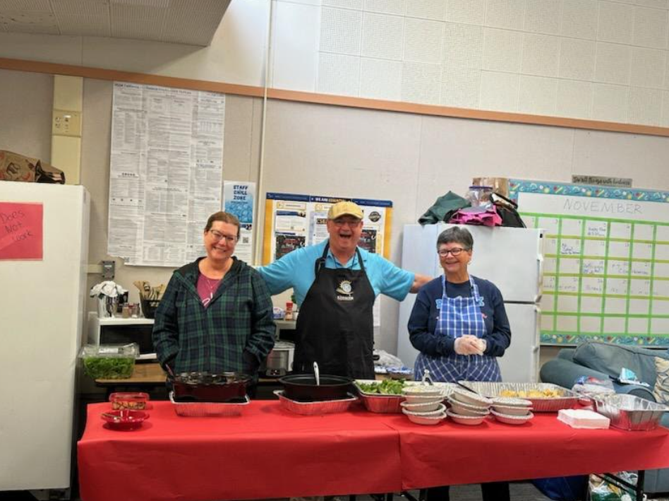
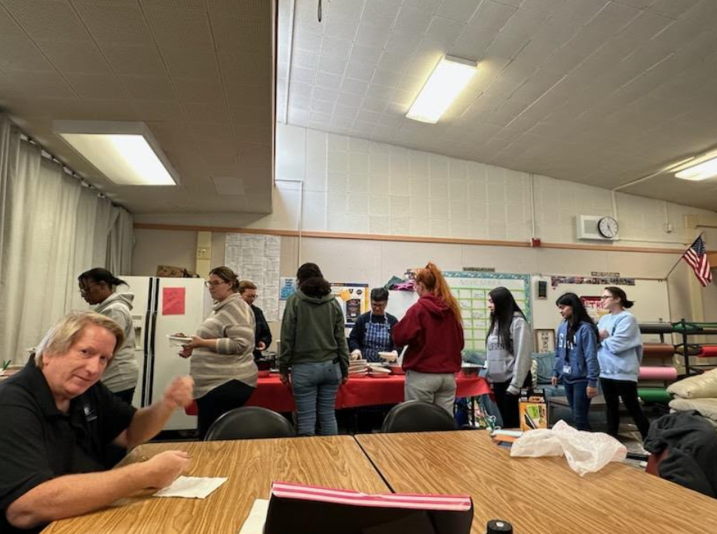

December Birthdays
- Armando Flores – Dec 12
- Kathy Morrow – Dec 19
Member Anniversaries
- Armando Flores – Oct 2015 (10 years)
- John Draper – Nov 2012 (13 years)
- Alex Telaro – Nov 2012 (13 years)
- Laurence Wilson – Nov 2012 (13 years)
- Naomi Medina – Dec 2021 (4 years)
Kiwanis Division 7 Calendar, check it out!
https://k0207.site.kiwanis.org/calendar/

…and more photos
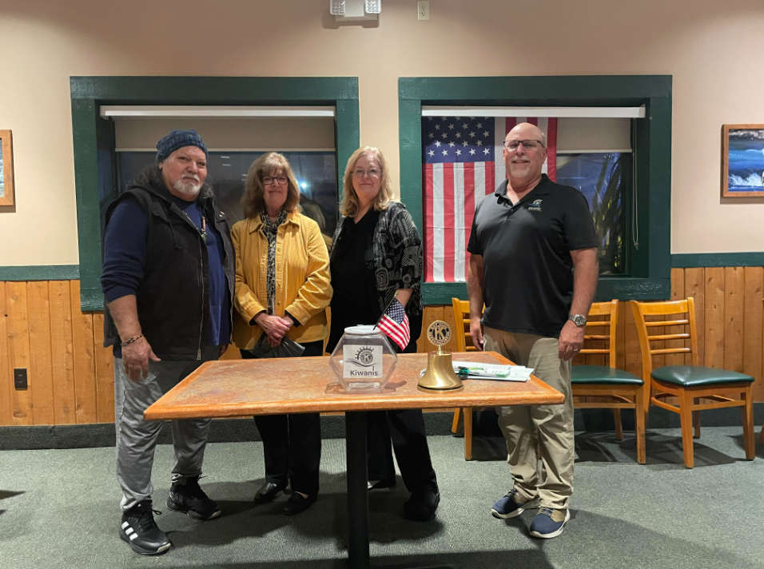
Last month’s official new member induction for Beverly Heironimus and Ginger Sylvester, with Dave Canady and sponsor Armando Flores.

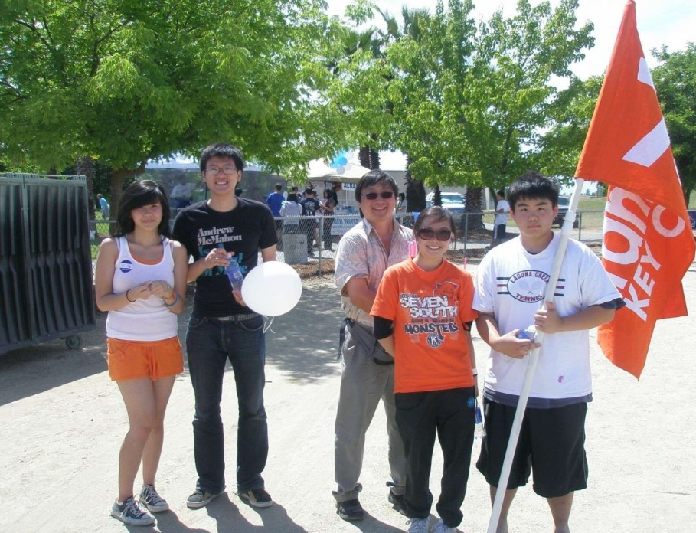
Blast from the past: Mark Shimada and daughter Megan with Franklin HS Key Club
The American Cancer Society’s Relay for Life event. What year was this?

Greater Sacramento’s Proposed Interclub Schedule – Rod Nishikawa

